Cheryllynn Walsh

Professor [Dr. Mark E. Lehr](https://app.maven.co/profile/xss7eEWk)

CIS-17B-47340

11 September 2017

[**Review 09/13/17**](https://rccdopencampus.blackboard.com/webapps/assignment/uploadAssignment?content_id=_3170134_1&course_id=_37601_1&assign_group_id=&mode=view)

1)  Obtain textbooks,

2)  Install Netbeans,

3)  Install Xampp,

4)  Run example code Cpp, Javascript, and PHP found at the class Github site, just like in class,

5)  Take a screen shot of the C++, Javascript and PHP output,

6) Send an email to mark.lehr@rcc.edu which copies yourself and attaches the screen shots with subject:  YourLastName, YourFirstName - Review 09/13/17 - 47340 or 48947.

7)  Also, post screenshots here in blackboard.

1. Obtain textbooks,
2. Install NetBeans

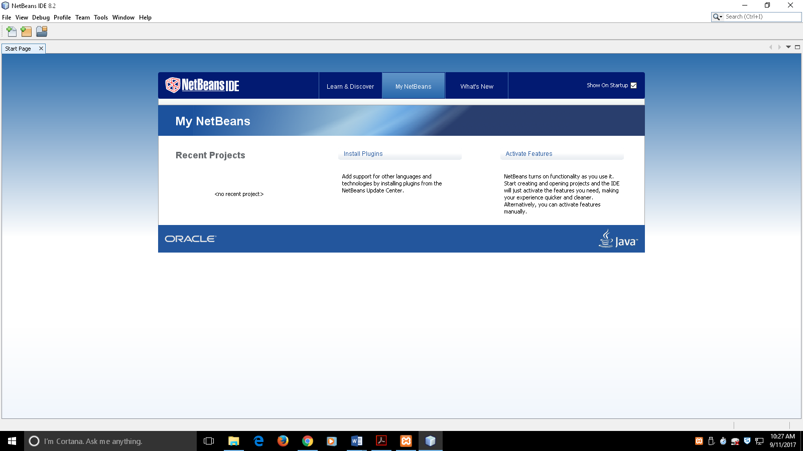

3. Install Xampp

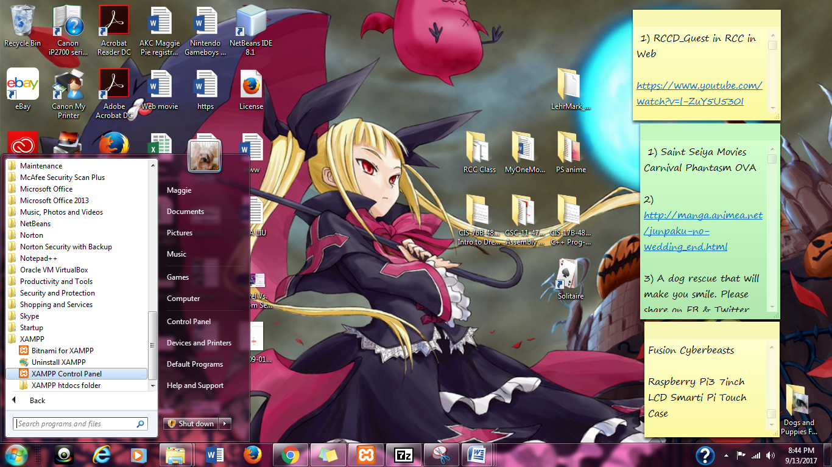

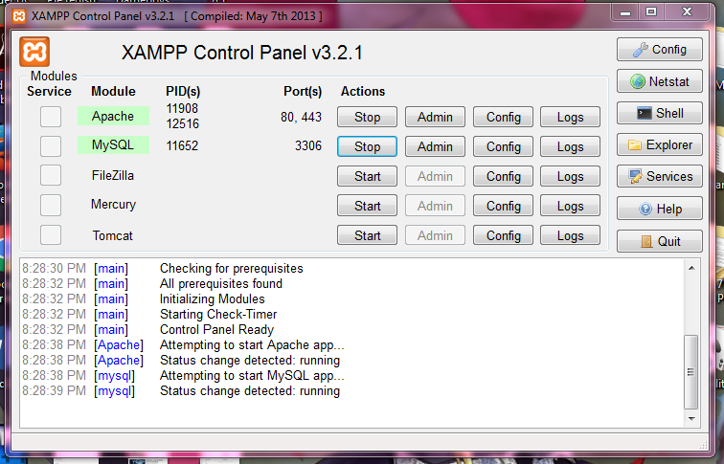

4. Run example code Cpp, JavaScript, and PHP found at the class GitHub site, just like in class

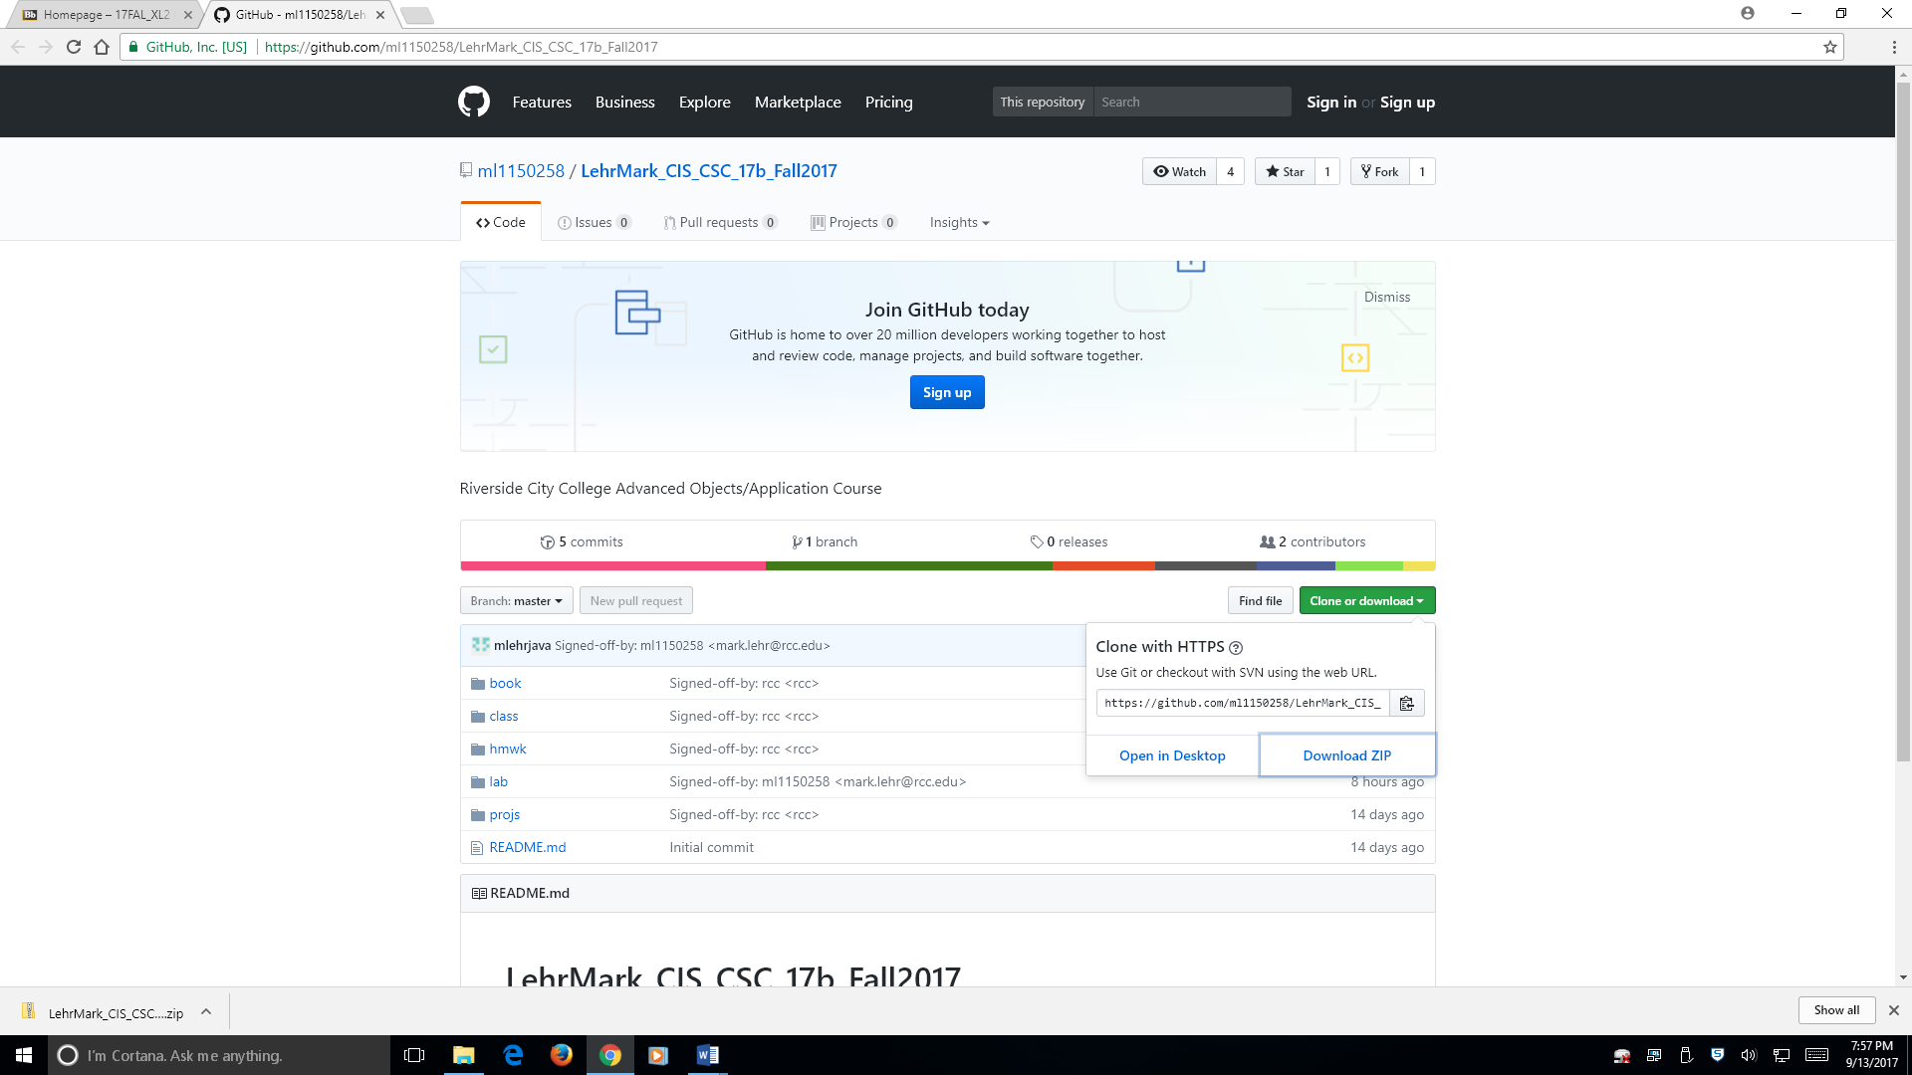

5. Take a screen shot of the C++, Javascript and PHP output,

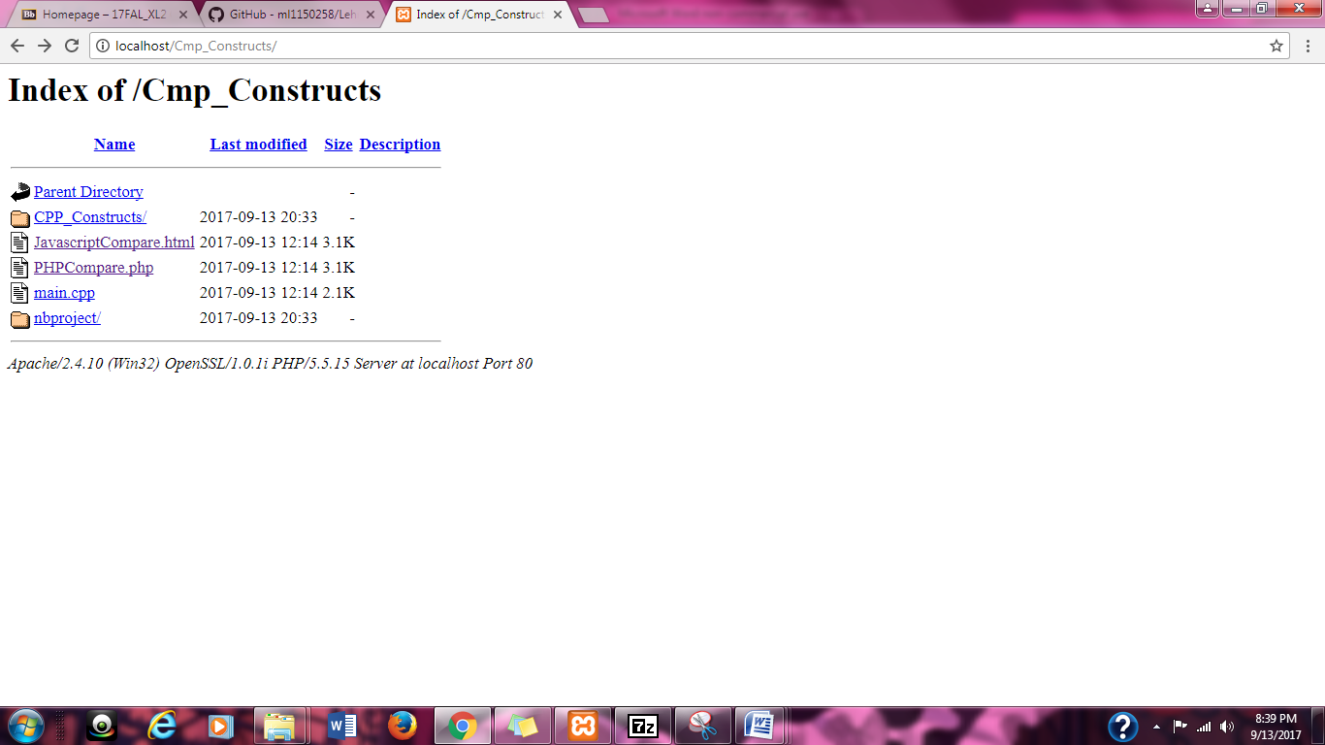

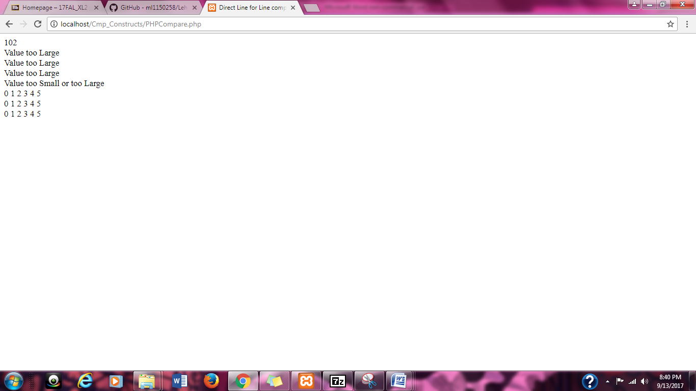

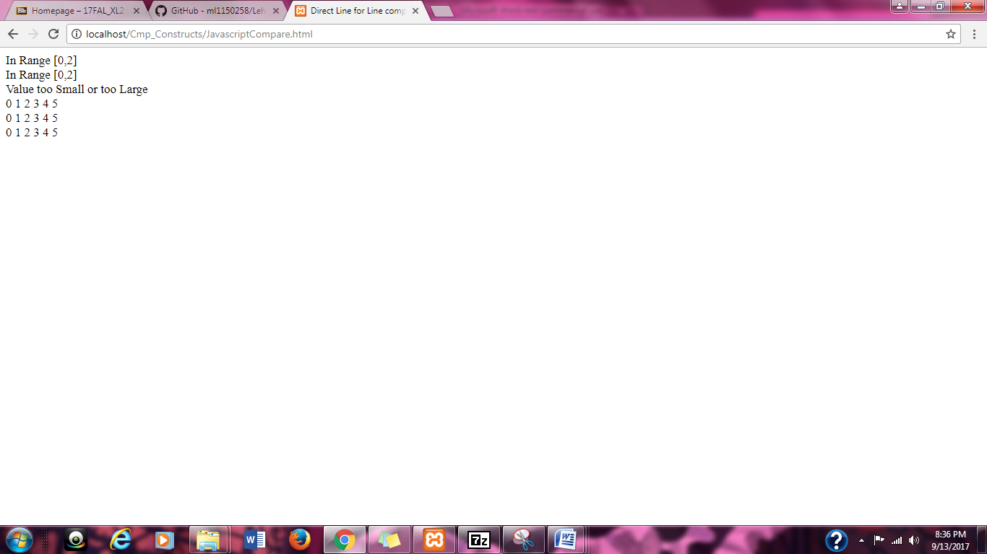

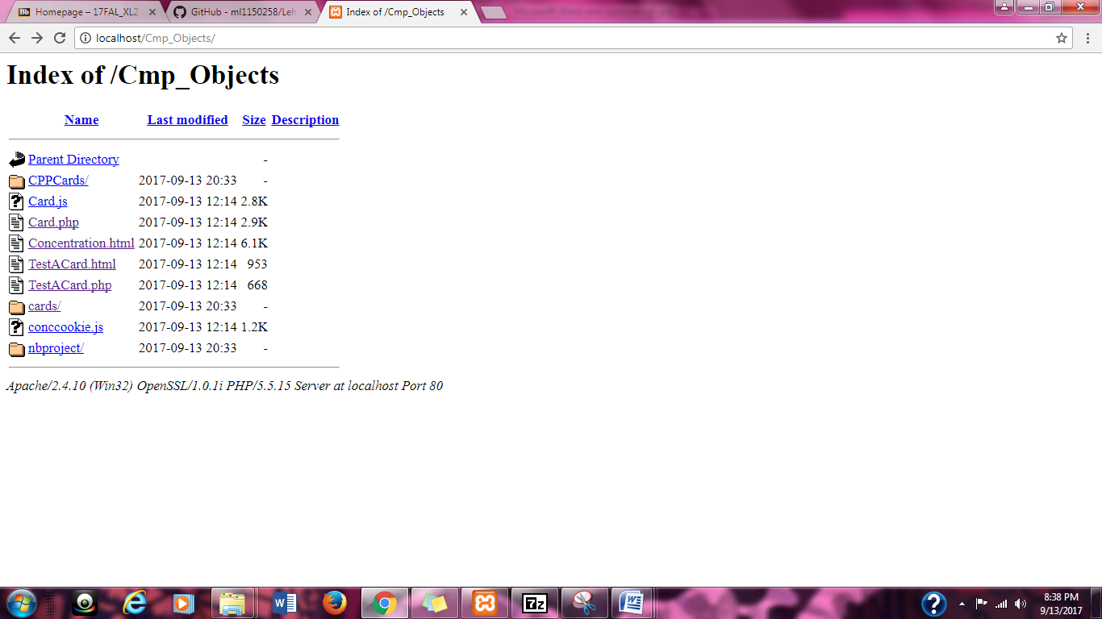

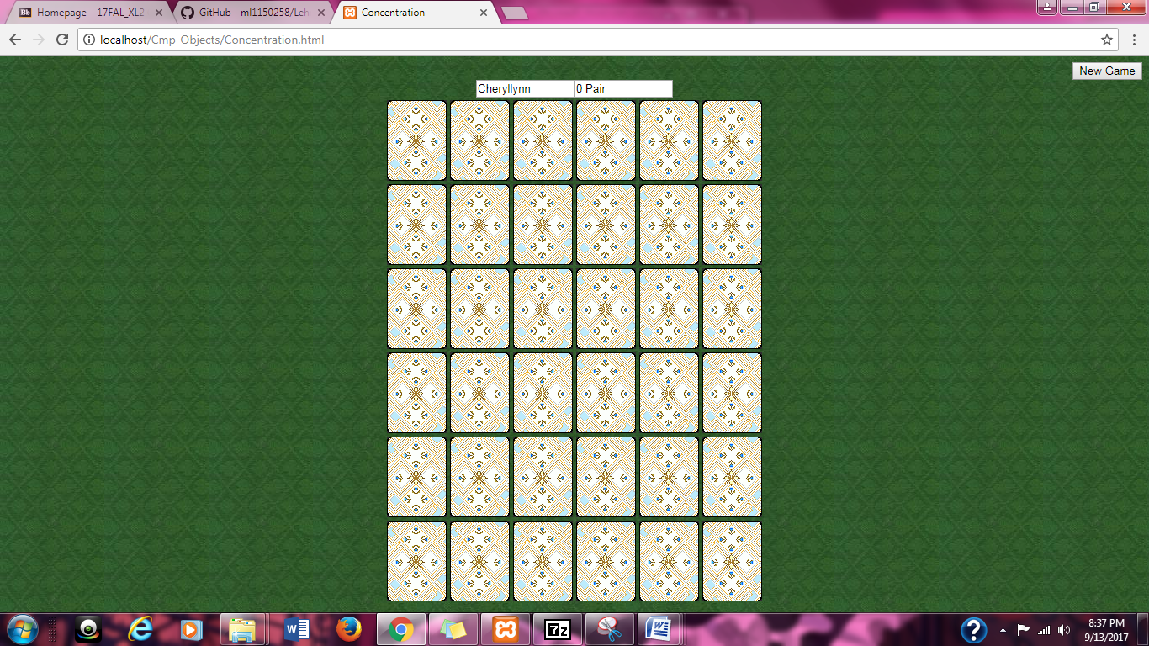

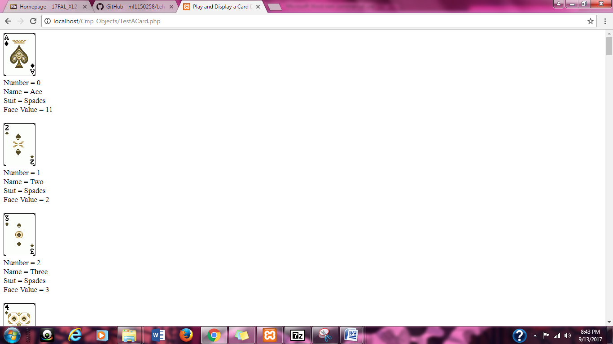

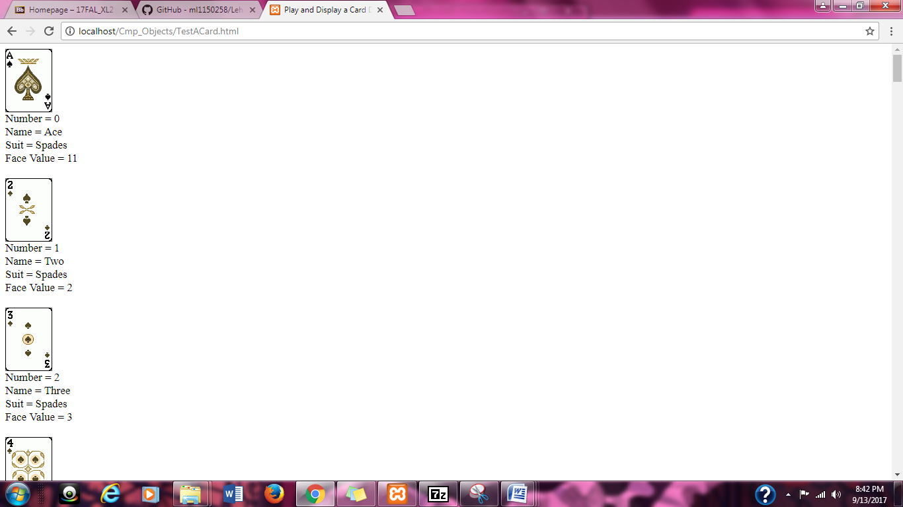

6.. Send an email to mark.lehr@rcc.edu which copies yourself and attaches the screen shots with subject:  YourLastName, YourFirstName - Review 09/13/17 - 47340 or 48947.